**FINAL EXAM SCREENSHOTS – TESTING SHEET:**

**MODELS:**

**SEEDING WAS SUCCESSFUL AND TABLES WERE FULLY LOADED.**

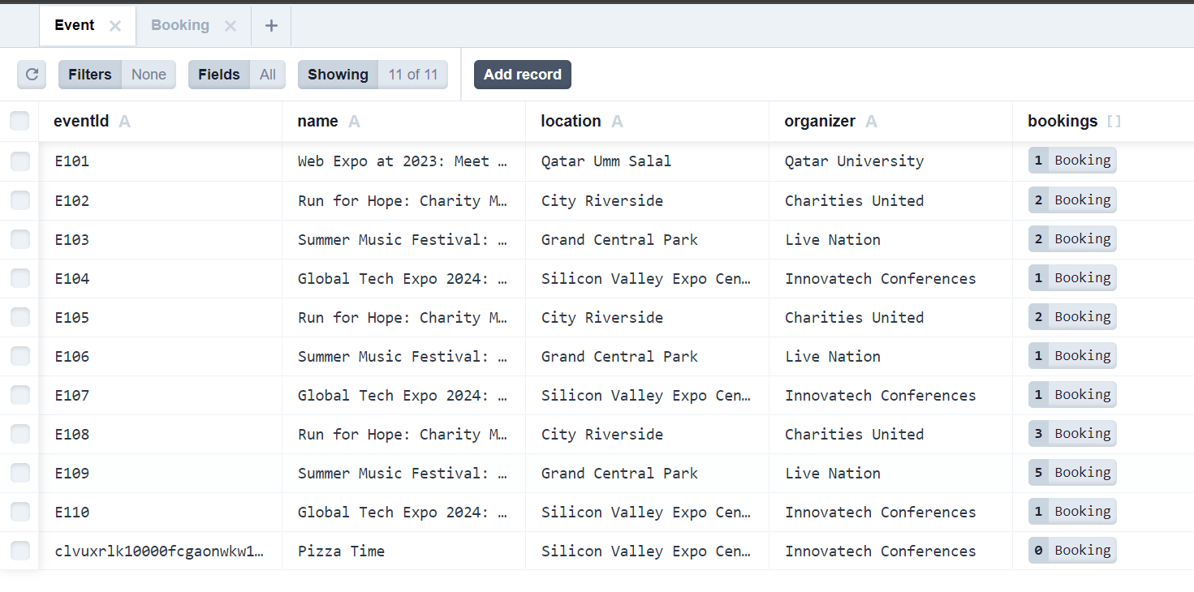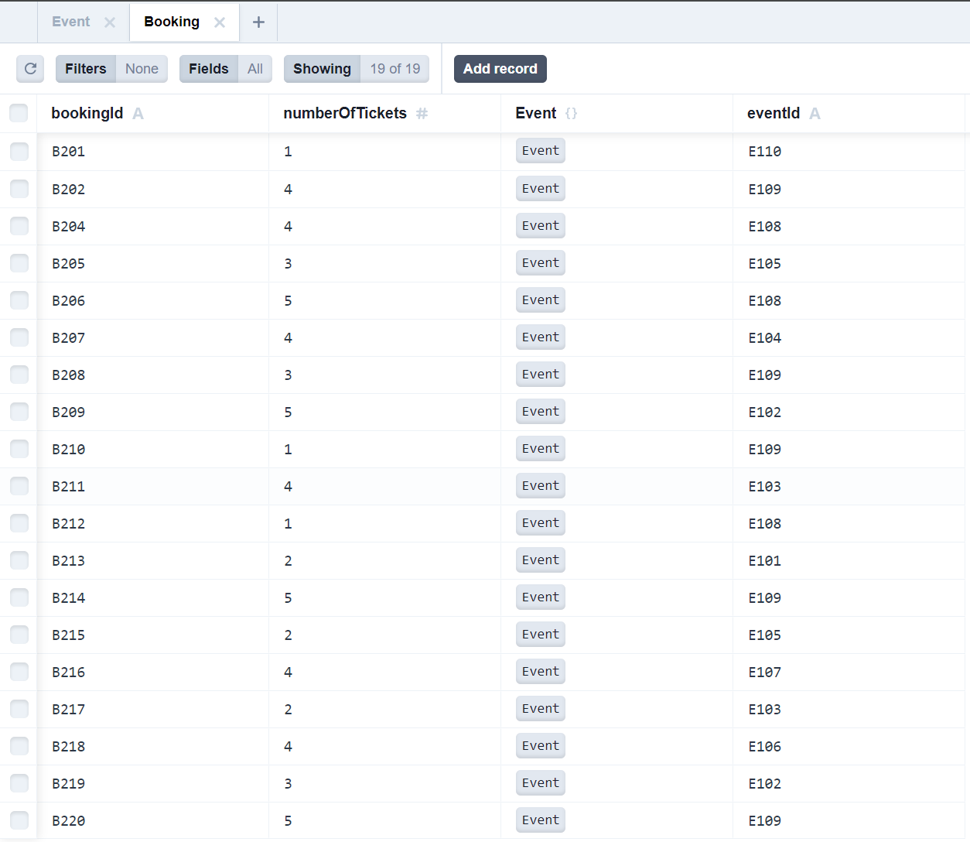

**REPO:**

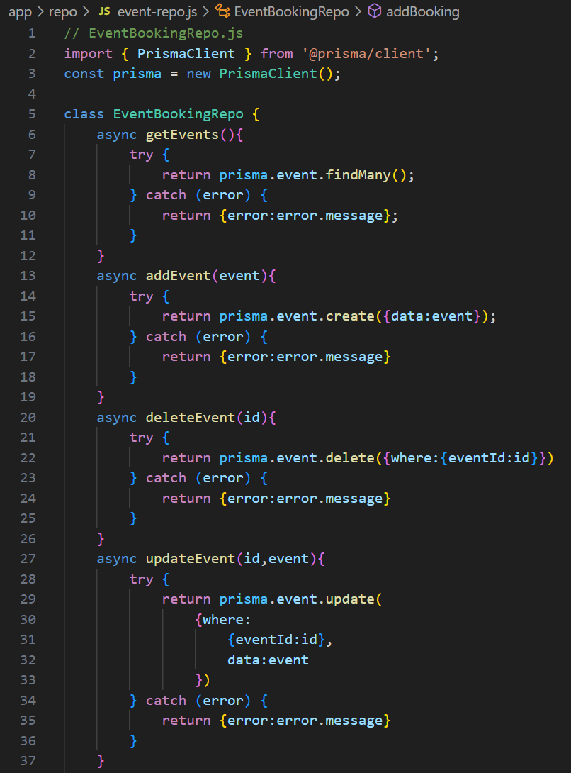

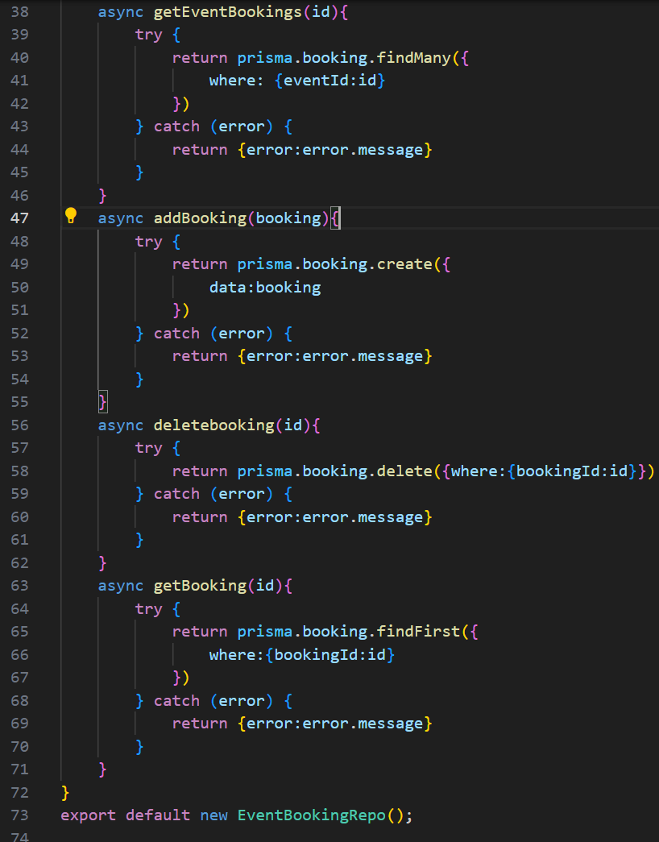

**API:**

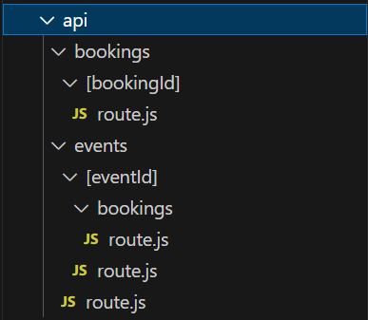 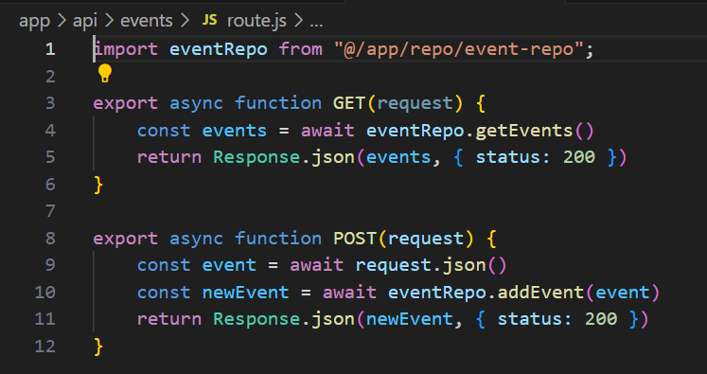

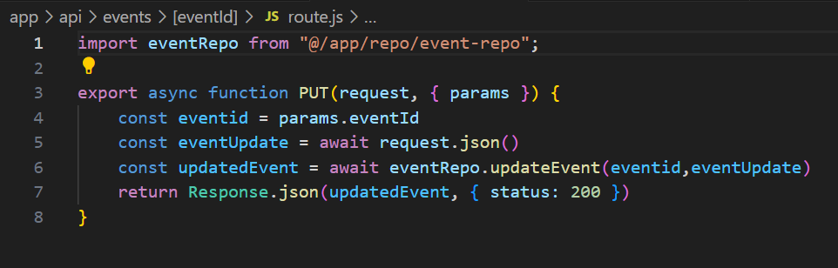 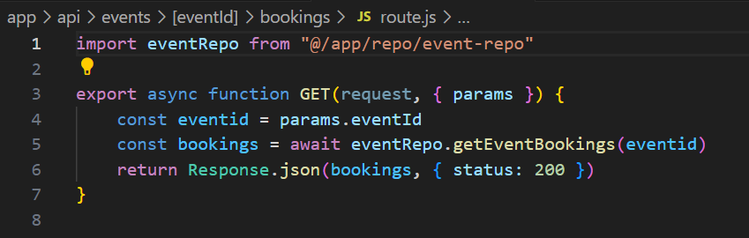

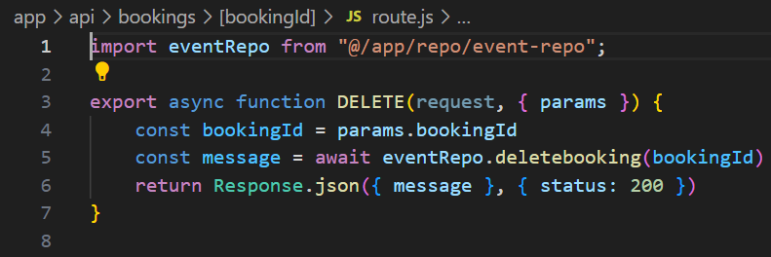

**POSTMAN:**

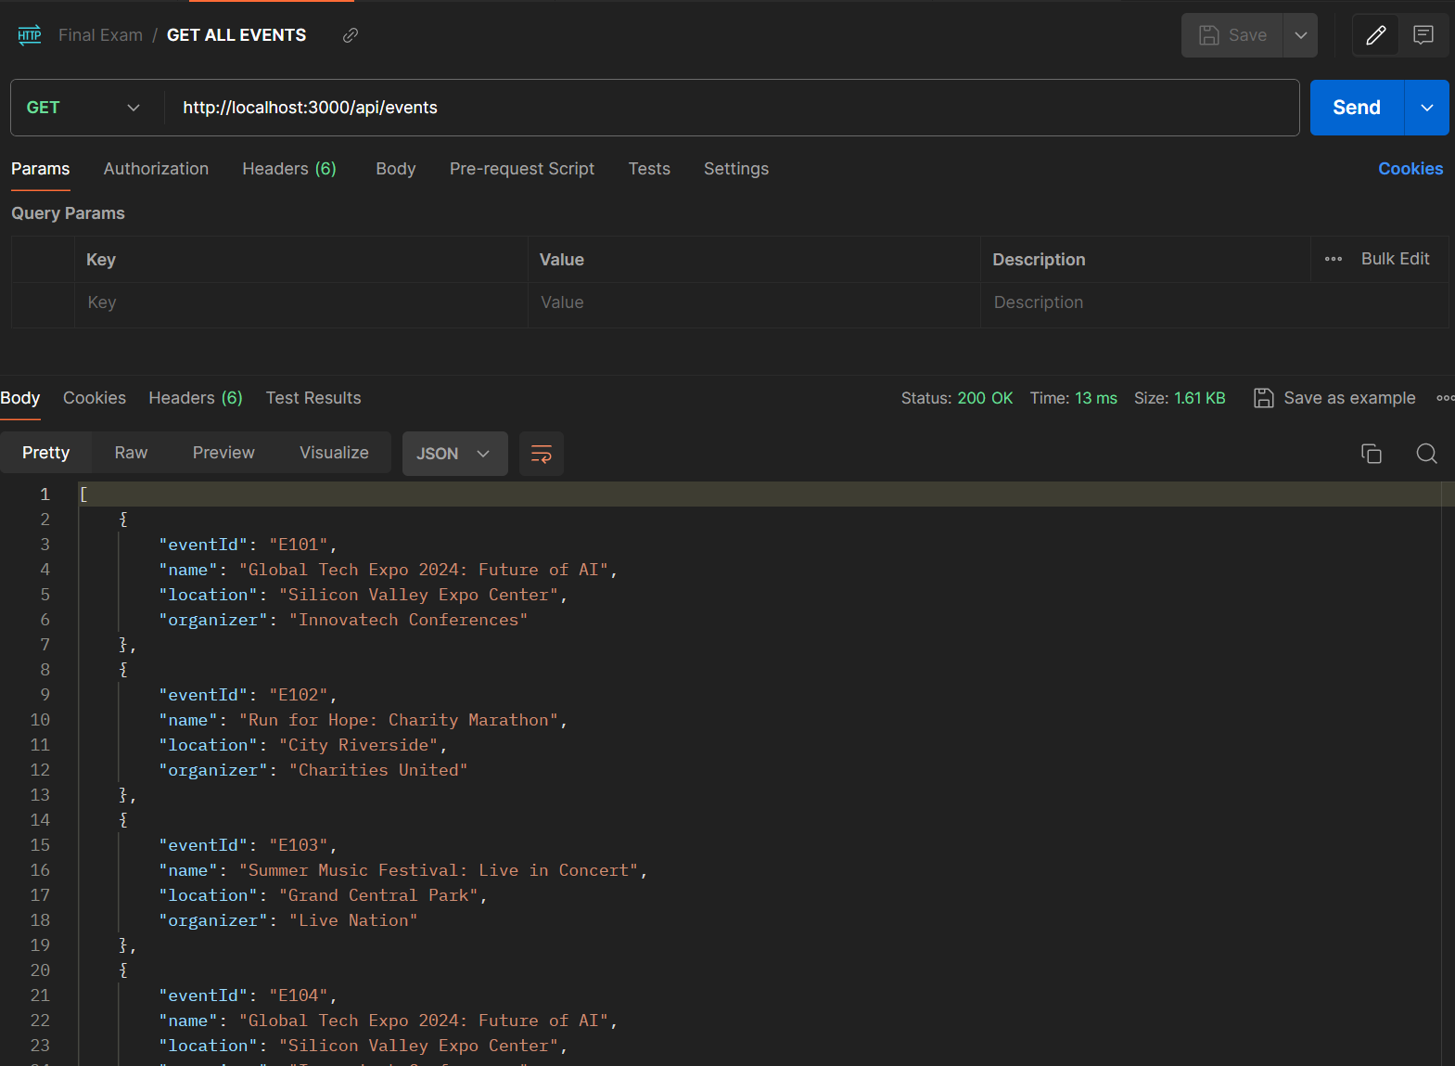

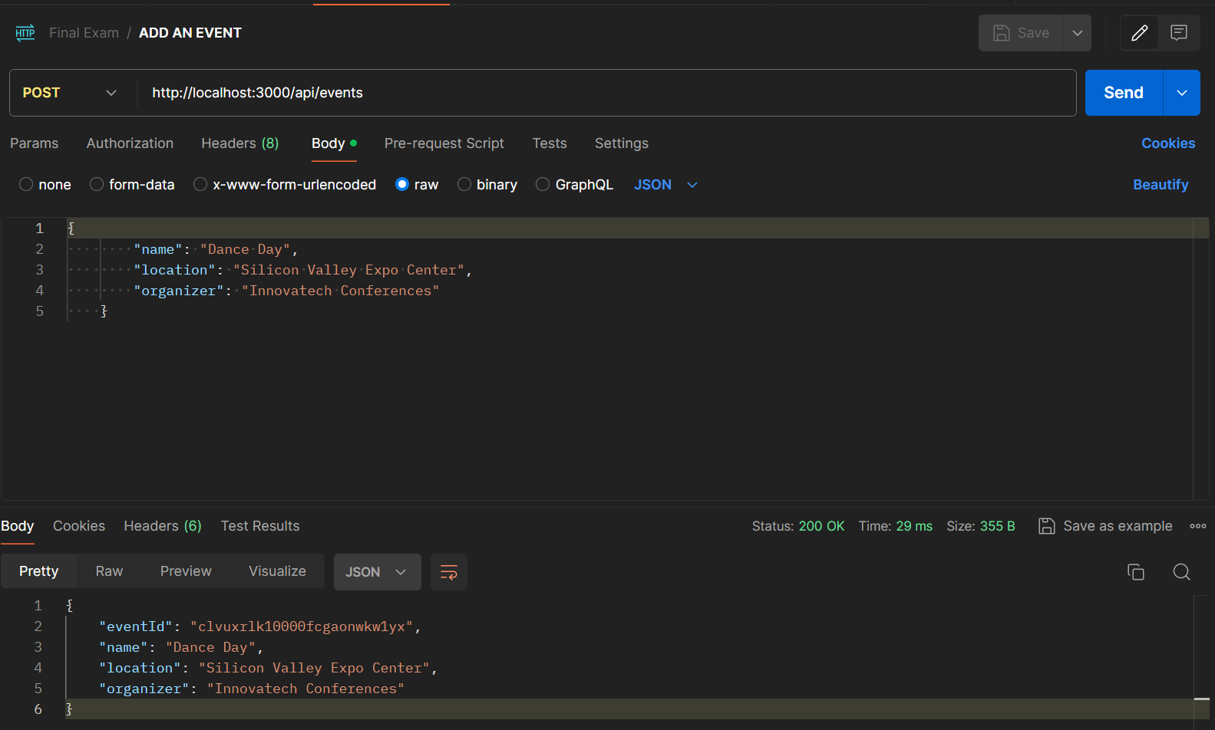

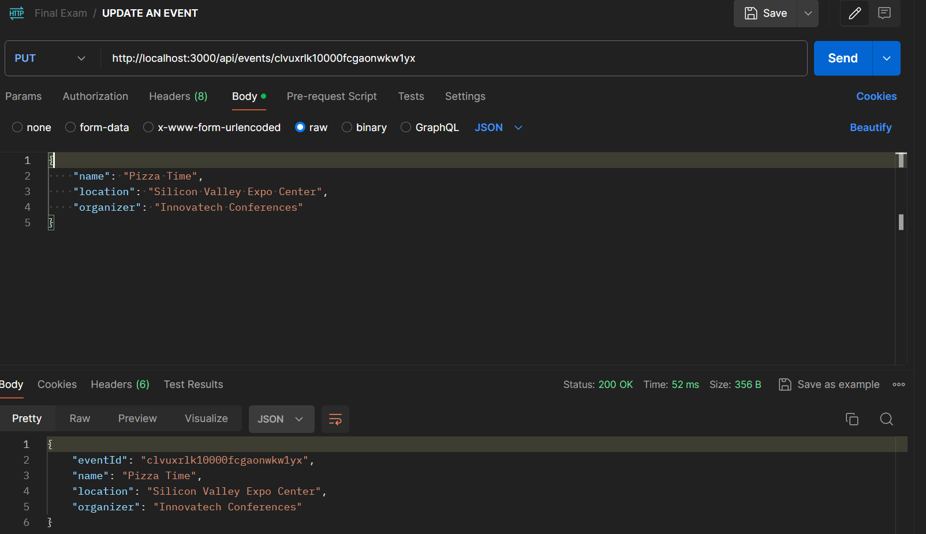

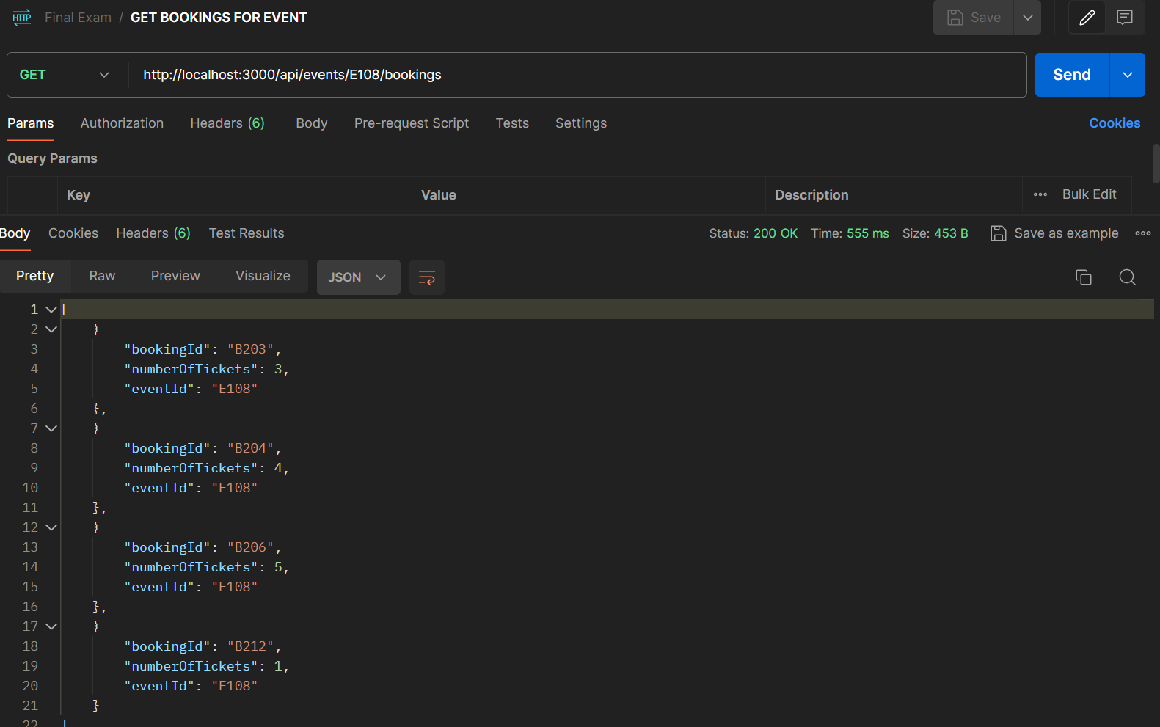

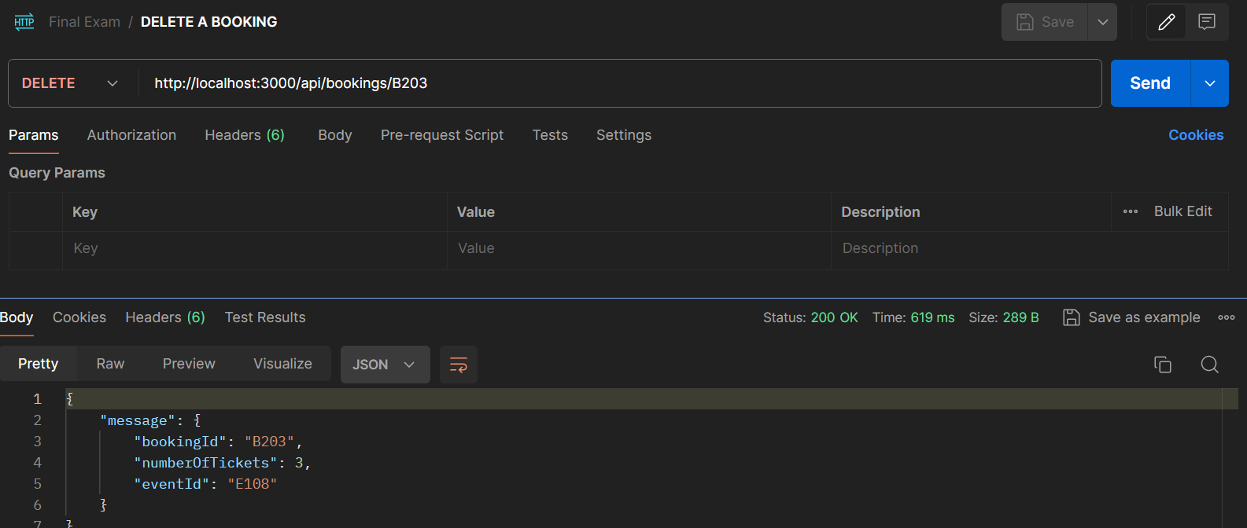

**UI:**

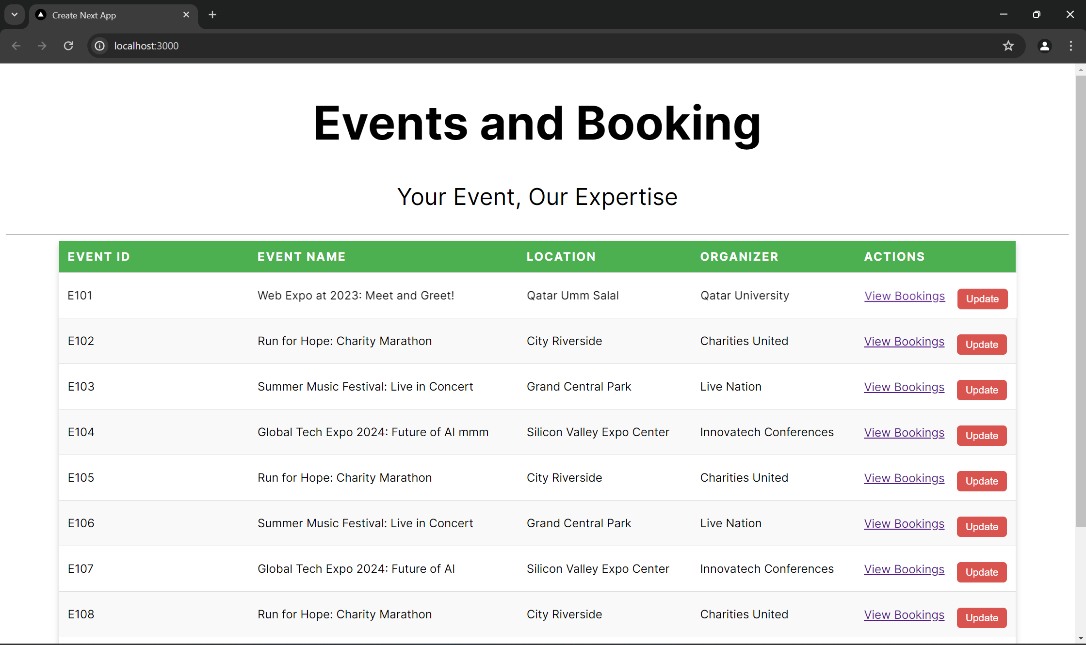

**I WILL UPDATE THE FIRST ONE.**

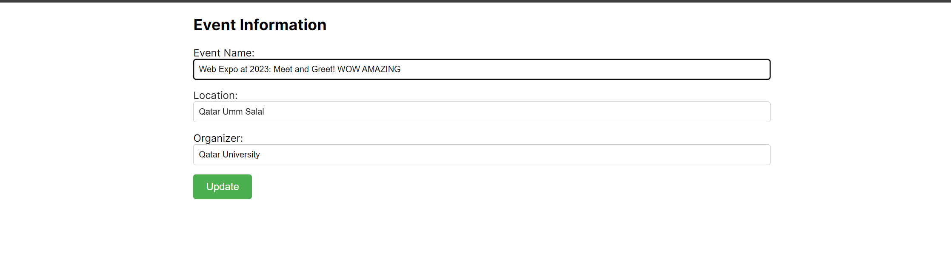

**AS WE CAN SEE, THE FIRST EVENT IS UPDATED.**

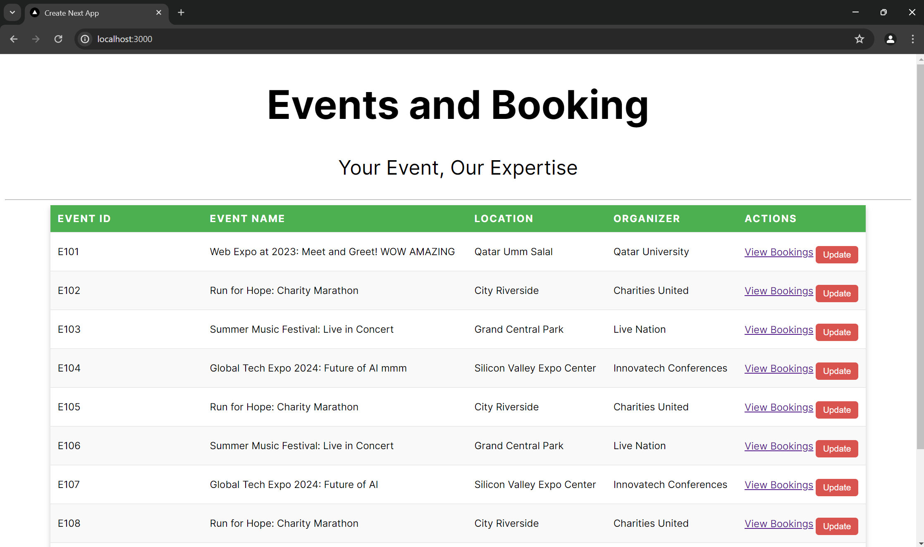

**NOW I WILL VIEW THE E108 EVENT:**

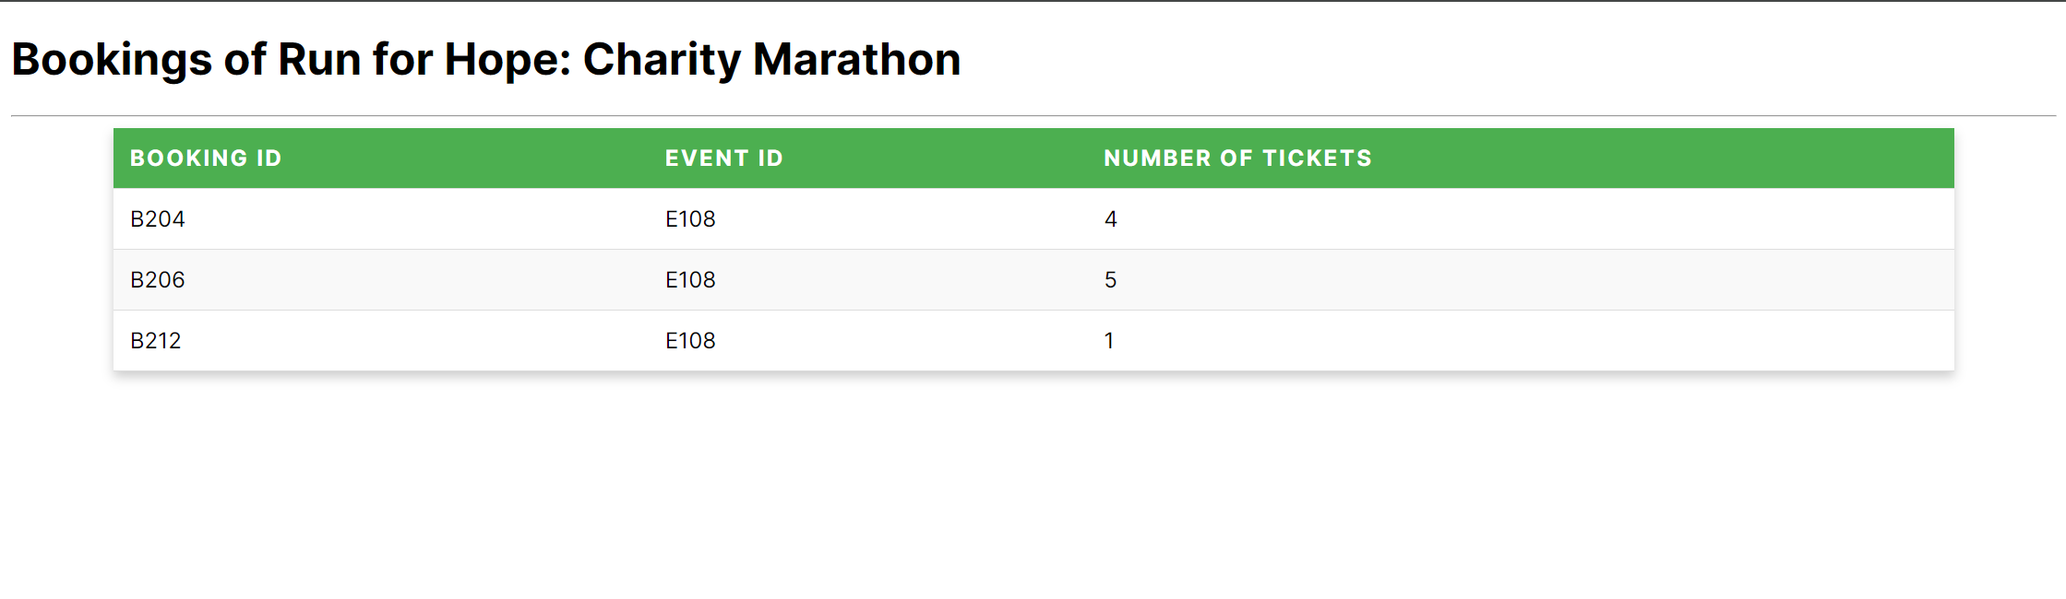

**NOW I WILL VIEW THE E104 EVENT:**

